**LAB - 2**

**MACHINE LEARNING**

**PRIYANSHU SHARMA**

**15BCE1282**

**DECISION TREE**

**CODE -**

import pandas as pd

data = pd.read_csv('C:/Users/PRIYANSHU SHARMA/Desktop/PRIYANSHU/6 STUDY/6 SEMSTER/MACHINE LEARNING/LAB/breast.csv')

data.head()

colnames=['ID', 'RADIUS', 'TEXTURE', 'PERIMETER', 'AREA', 'SMOOTHNESS', 'COMPACTNESS', 'CONCAVITY', 'CONCAVE', 'SYMMETRY', 'FRACTAL']

data = pd.read_csv('C:/Users/PRIYANSHU SHARMA/Desktop/PRIYANSHU/6 STUDY/6 SEMSTER/MACHINE LEARNING/LAB/breast.csv', names=colnames, header=None)

data.head()

print(data.columns)

data.describe()

# DECISION TREE IMPLEMENTATION

from sklearn.tree import DecisionTreeClassifier

from sklearn.model_selection import train_test_split

print(data.columns)

columns=['RADIUS', 'TEXTURE', 'PERIMETER', 'AREA', 'SMOOTHNESS', 'COMPACTNESS', 'CONCAVITY', 'CONCAVE', 'SYMMETRY']

a=data[columns].iloc[:,:9].values #all columns in array

a

b=data[columns].iloc[:,0:1].values #label column in array (particular column selection)

X_train,X_test,Y_train,Y_test = train_test_split(data[columns],data['FRACTAL'],test_size=0.4,random_state=14)

tree = DecisionTreeClassifier(max_depth=7,random_state=0)

tree.fit(X_train,Y_train)

print("Accuracy on the training set: %.3f" % tree.score(X_train,Y_train))

print("Accuracy on the testing set: %.3f" % tree.score(X_test,Y_test))

from sklearn.tree import export_graphviz

export_graphviz(tree, out_file="tree.dot", class_names=['2','4'], impurity=False, filled=True, feature_names=data[columns].columns)

import graphviz

with open("tree.dot") as f:

dot_graph = f.read()

graphviz.Source(dot_graph)

**OUTPUT**

**\*\*MY OUTPUT DECISION TREE IS BASED ON (wisconsin breast cancer datasets)**

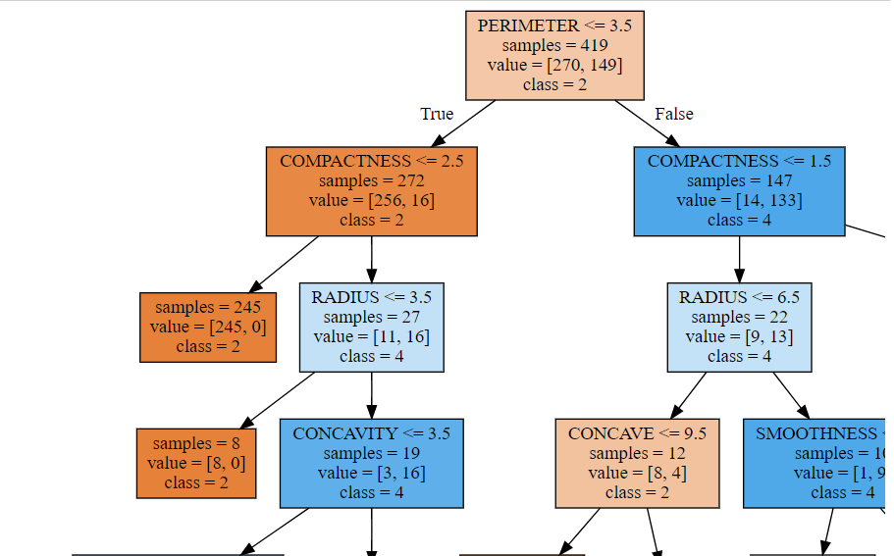

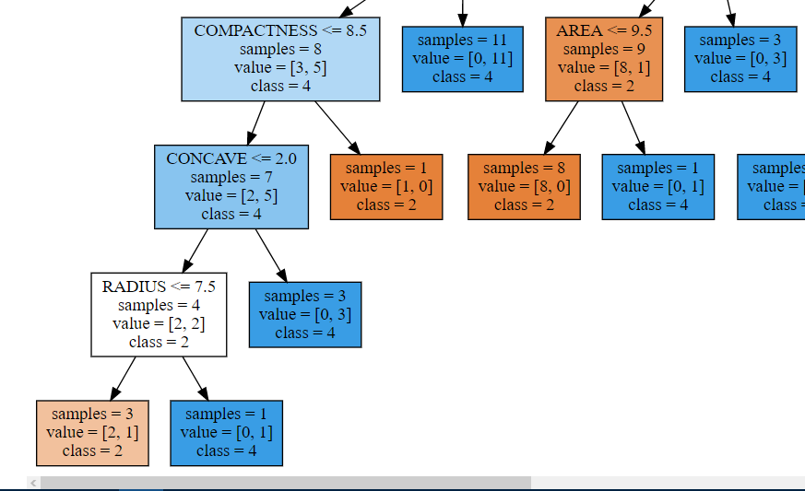

**LINEAR REGRESSION**

**CODE -**

#LINEAR REGRESSION

import pandas as pd

data = pd.read_csv('C:/Users/PRIYANSHU SHARMA/Desktop/PRIYANSHU/6 STUDY/6 SEMSTER/MACHINE LEARNING/LAB/breast.csv')

data.head()

colnames=['ID', 'RADIUS', 'TEXTURE', 'PERIMETER', 'AREA', 'SMOOTHNESS', 'COMPACTNESS', 'CONCAVITY', 'CONCAVE', 'SYMMETRY', 'FRACTAL']

data = pd.read_csv('C:/Users/PRIYANSHU SHARMA/Desktop/PRIYANSHU/6 STUDY/6 SEMSTER/MACHINE LEARNING/LAB/breast.csv', names=colnames, header=None)

data.head()

import matplotlib.pyplot as plt

import seaborn as sb

sb.set(style='whitegrid', context='notebook')

cols = ['SMOOTHNESS', 'SYMMETRY', 'CONCAVE', 'PERIMETER', 'AREA']

sb.pairplot(data[cols], size=2.5);

plt.show()

import numpy as np

cm = np.corrcoef(data[cols].values.T)

sb.set(font_scale=1.5)

hm = sb.heatmap(cm, cbar=True, annot=True, square=True, fmt='.2f', annot_kws={'size': 15}, yticklabels=cols, xticklabels=cols)

plt.show()

from sklearn import datasets, linear_model

from sklearn.linear_model import LinearRegression

X = data[['CONCAVE']].values

Y = data[['AREA']].values

regr = linear_model.LinearRegression()

regr.fit(X, Y)

plt.scatter(X, Y, color='black')

plt.plot(X, regr.predict(X), color='blue', linewidth=3)

plt.xticks(())

plt.yticks(())

plt.show()

regr.coef_ #slope

regr.intercept_ #intercept

print('Slope: %.3f' % regr.coef_[0])

print('Intercept: %.3f' % regr.intercept_[0])

class LinearRegressionGD(object):

def __init__(self, eta=0.001, n_iter=20):

self.eta = eta

self.n_iter = n_iter

def fit(self, X, y):

self.w_ = np.zeros(1 + X.shape[1])

self.cost_ = []

for i in range(self.n_iter):

output = self.net_input(X)

errors = (y - output)

self.w_[1:] += self.eta * X.T.dot(errors)

self.w_[0] += self.eta * errors.sum()

cost = (errors**2).sum() / 2.0

self.cost_.append(cost)

return self

def net_input(self, X):

return np.dot(X, self.w_[1:]) + self.w_[0]

def predict(self, X):

return self.net_input(X)

from sklearn.preprocessing import StandardScaler

def lin_regplot(X, y, model):

plt.scatter(X, y, c='blue')

plt.plot(X, model.predict(X), color='red')

return None

lin_regplot(X, Y, regr)

plt.xlabel('CONCAVE')

plt.ylabel('AREA')

plt.show()

data['CONCAVE'].unique()

data['AREA'].unique()

area_std = regr.predict(12)

print("AREA: %.3f" %area_std)

**OUTPUT**

**\*\*MY OUTPUT DECISION TREE IS BASED ON (wisconsin breast cancer datasets)**

Slope: 0.564

Intercept: 1.189

**PREDICATED DATA VALUE -**

AREA: 7.960 (**FOR CONCAVE = 12**)

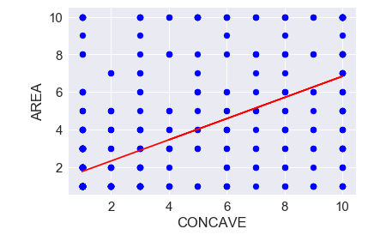

**QUESTION - 1 POKEMON URBAN DATASET**

**CODE -**

import pandas as pd

import matplotlib.pyplot as plt

colnames=['ITEM', 'POKEMON','URBAN']

data = pd.read_csv('C:/Users/PRIYANSHU SHARMA/Desktop/PRIYANSHU/6 STUDY/6 SEMSTER/MACHINE LEARNING/LAB/pokeurban.csv', names=colnames, header=None)

data.head()

from sklearn import datasets, linear_model

from sklearn.linear_model import LinearRegression

X = data[['POKEMON']].values

Y = data[['URBAN']].values

regr = linear_model.LinearRegression()

regr.fit(X, Y)

plt.scatter(X, Y, color='black')

plt.plot(X, regr.predict(X), color='blue', linewidth=3)

plt.xticks(())

plt.yticks(())

plt.show()

regr.coef_ #slope

regr.intercept_ #intercept

print('Slope: %.3f' % regr.coef_[0])

print('Intercept: %.3f' % regr.intercept_[0])

def lin_regplot(X, y, model):

plt.scatter(X, y, c='blue')

plt.plot(X, model.predict(X), color='red')

return None

lin_regplot(X, Y, regr)

plt.xlabel('POKEMON')

plt.ylabel('URBAN')

plt.show()

urban_std = regr.predict(40) #when pokemon = 40

print("URBAN: %.3f" %urban_std)

**OUTPUT**

**\*\*MY OUTPUT DECISION TREE IS BASED ON (pokemon urban datasets)**

Slope: 0.385

Intercept: 65.142

**PREDICATED DATA VALUE -**

URBAN: 80.551 (**FOR POKEMON = 40**)

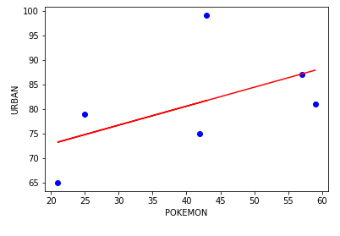

**QUESTION - 1 LENGTH MILEAGE DATASET**

**CODE -**

import pandas as pd

import matplotlib.pyplot as plt

colnames=['LENGTH', 'MILEAGE']

data = pd.read_csv('C:/Users/PRIYANSHU SHARMA/Desktop/PRIYANSHU/6 STUDY/6 SEMSTER/MACHINE LEARNING/LAB/mileagecar.csv', names=colnames, header=None)

data.head()

from sklearn import datasets, linear_model

from sklearn.linear_model import LinearRegression

X = data[['LENGTH']].values

Y = data[['MILEAGE']].values

regr = linear_model.LinearRegression()

regr.fit(X, Y)

plt.scatter(X, Y, color='black')

plt.plot(X, regr.predict(X), color='blue', linewidth=3)

plt.xticks(())

plt.yticks(())

plt.show()

regr.coef_ #slope

regr.intercept_ #intercept

print('Slope: %.3f' % regr.coef_[0])

print('Intercept: %.3f' % regr.intercept_[0])

def lin_regplot(X, y, model):

plt.scatter(X, y, c='blue')

plt.plot(X, model.predict(X), color='red')

return None

lin_regplot(X, Y, regr)

plt.xlabel('LENGTH')

plt.ylabel('MILEAGE')

plt.show()

mileage_std = regr.predict(200) #when MILEAGE = 200

print("MILEAGE: %.3f" %mileage_std)

**OUTPUT**

**\*\*MY OUTPUT DECISION TREE IS BASED ON (length mileage datasets)**

Slope: -0.232

Intercept: 64.763

**PREDICATED DATA VALUE -**

MILEAGE: 18.357 **(FOR LENGTH = 200)**

